Batch: A-3 Roll No.: 16010122104
Experiment No. 1

Grade: AA / AB / BB / BC / CC / CD /DD

Title: Study of Cloud Computing & Architecture

Objective:

Expected Outcome of Experiment:

CO | Outcome
CO1 | Comprehend the issues related to cloud computing and its application

Books/ Journals/ Websites referred:

Related Theory: -
Study Types of Computing

Key Types of Computing
- Cloud Computing: This model allows users to access data and applications over the internet, promoting scalability and cost efficiency. Examples include Google Drive and Amazon Web Services.
- Grid Computing: Involves connecting multiple computers to solve large problems collaboratively, often used in scientific research.
- Distributed Computing: Several computers work on a single problem independently, improving performance through parallel processing.
- Cluster Computing: Groups of closely located computers work together as a powerful system, commonly used in scientific simulations and financial modeling.
- Personal Computing: Refers to the use of desktops and laptops for everyday tasks, enabling independence in personal and professional activities.
- Time-Sharing Computing: A central system is shared among multiple users by dividing processing time, making it resource-efficient.
- Client-Server Computing: A network configuration where clients request services from a central server, widely used in web applications.
- Peer-to-Peer (P2P) Computing: Devices communicate directly without a central server, enhancing privacy and decentralization.
- Mobile Computing: The ability to use computing resources on portable devices, allowing for flexibility and immediate access to information.

Source:https://www.weetechsolution.com/blog/types-of-computing

NIST(3-4-5) Definition of Cloud

Cloud computing is a model for enabling ubiquitous, convenient, on-demand network access to a shared pool of configurable computing resources (e.g., networks, servers, storage, applications, and services) that can be rapidly provisioned and released with minimal management effort or service provider interaction.
This cloud model is composed of five essential characteristics, three service models, and four deployment models.

Essential Characteristics:
- On-demand self-service: Users can provision resources automatically without human interaction.
- Broad network access: Resources are accessible via standard mechanisms across various devices.
- Resource pooling: Resources are pooled to serve multiple consumers dynamically.
- Rapid elasticity: Resources can be scaled up or down quickly based on demand.
- Measured service: Resource usage is monitored and reported for transparency.
Service Models:
- Software as a Service (SaaS): Users access applications hosted on the cloud without managing the underlying infrastructure.
- Platform as a Service (PaaS): Users deploy applications created by themselves or acquired on the cloud infrastructure.
- Infrastructure as a Service (IaaS): Users provision fundamental computing resources and have control over operating systems and deployed applications.
Deployment Models:
- Private Cloud: Exclusive use by a single organization, which may be managed internally or by a third party.
- Community Cloud: Shared infrastructure for specific communities with common concerns.
- Public Cloud: Open use by the general public, managed by various organizations.
- Hybrid Cloud: Combination of two or more distinct cloud infrastructures that remain unique but are interconnected.
Source: https://nvlpubs.nist.gov/nistpubs/legacy/sp/nistspecialpublication800-145.pdf

Evolution of Cloud Computing
The concept of cloud computing dates back to the 1950s and has evolved through several stages:
- Distributed Systems: Involves interconnected systems that share resources and communicate over networks.
- Mainframe Computing: Established in 1951, it handles vast amounts of data but is costly.
- Cluster Computing: Connects multiple computers (nodes) to work as a single system, enhancing performance and reducing costs.
- Grid Computing: Introduced in the 1990s, it connects geographically dispersed nodes over the internet, addressing some limitations of cluster computing.
- Web 2.0: Allows users to generate and share content through social media platforms, marking a shift in user interaction online.
- Virtualization: A technique that uses a software layer over hardware to provide cloud services, gaining prominence in IT.
- Utility Computing: Offers data storage on a rental basis according to user needs.
Source: https://www.tutorialspoint.com/evolution-of-cloud-computing

Studying the various file service storage providers that offer cloud storage, file synchronization and client software
Provider | Free Storage | 1TB Monthly Cost | Key Features | Security Features | Ideal For
IDrive | 10GB | $1.02 | Robust backup features, sync & sharing | Zero-knowledge encryption (optional) | Users needing strong backup capabilities
Cyfuture Cloud | N/A | ₹690 (~$8.30) | Managed cloud hosting, high-performance servers | Multi-layered security | Businesses requiring reliable hosting solutions
Sync.com | 5GB | $4.00 | End-to-end encryption, excellent file versioning | Zero-knowledge encryption | Privacy-conscious users
pCloud | 10GB | $4.17 | Fast synchronization, lifetime plans available | Paid private encryption | Users looking for long-term storage solutions
Icedrive | 10GB | $4.99 | Modern interface, Twofish encryption | Zero-knowledge encryption | Users valuing privacy and security
Google Drive | 15GB | $4.17 | Cloud collaboration, Google Workspace integration | Standard security measures | Users integrated into the Google ecosystem
MEGA | 20GB | $4.75 | Emphasis on privacy, end-to-end encryption | End-to-end encryption | Users prioritizing security
Dropbox | 2GB | $4.99 | Collaborative tools, file sharing | Standard security measures | Teams needing collaboration
OneDrive | 5GB | $5.83 | Seamless integration with Microsoft software | Standard security measures | Microsoft users
Koofr | N/A | $11.80 | Compatibility with other cloud services | Standard security measures | Users needing simple usage
DigiBoxx | N/A | ₹30 (~$0.36) | Designed for Indian users, cost-effective | Standard security measures | Indian users needing affordable options
Zoolz Cloud Storage | N/A | ₹225 (~$2.73) | Cold storage option for infrequently accessed files | Standard security measures | Users needing to store large amounts of data

Source: https://www.cloudwards.net/comparison/
https://www.finout.io/blog/cloud-storage-pricing-comparison
List the common features included in DaaS
- Data Accessibility: Access data from anywhere via the internet, facilitating remote work and collaboration.
- Data Integration: Combine data from various sources into a unified platform for comprehensive analysis.
- Data Processing and Transformation: Cleanse and enrich data to ensure high quality and consistency.
- Scalability: Easily adjust data resources based on changing business needs without infrastructure constraints.
- Security and Compliance: Implement advanced security measures and ensure adherence to industry regulations.
- Cost Efficiency: Reduce capital expenditures with a subscription model, making IT costs predictable.
- Business Continuity and Backup: Regular backups protect data and ensure recoverability in case of failures.
- Enhanced Data Quality: Mechanisms for data cleansing improve reliability and accuracy of insights.
Source: https://www.geeksforgeeks.org/overview-of-desktop-as-a-service-daas/

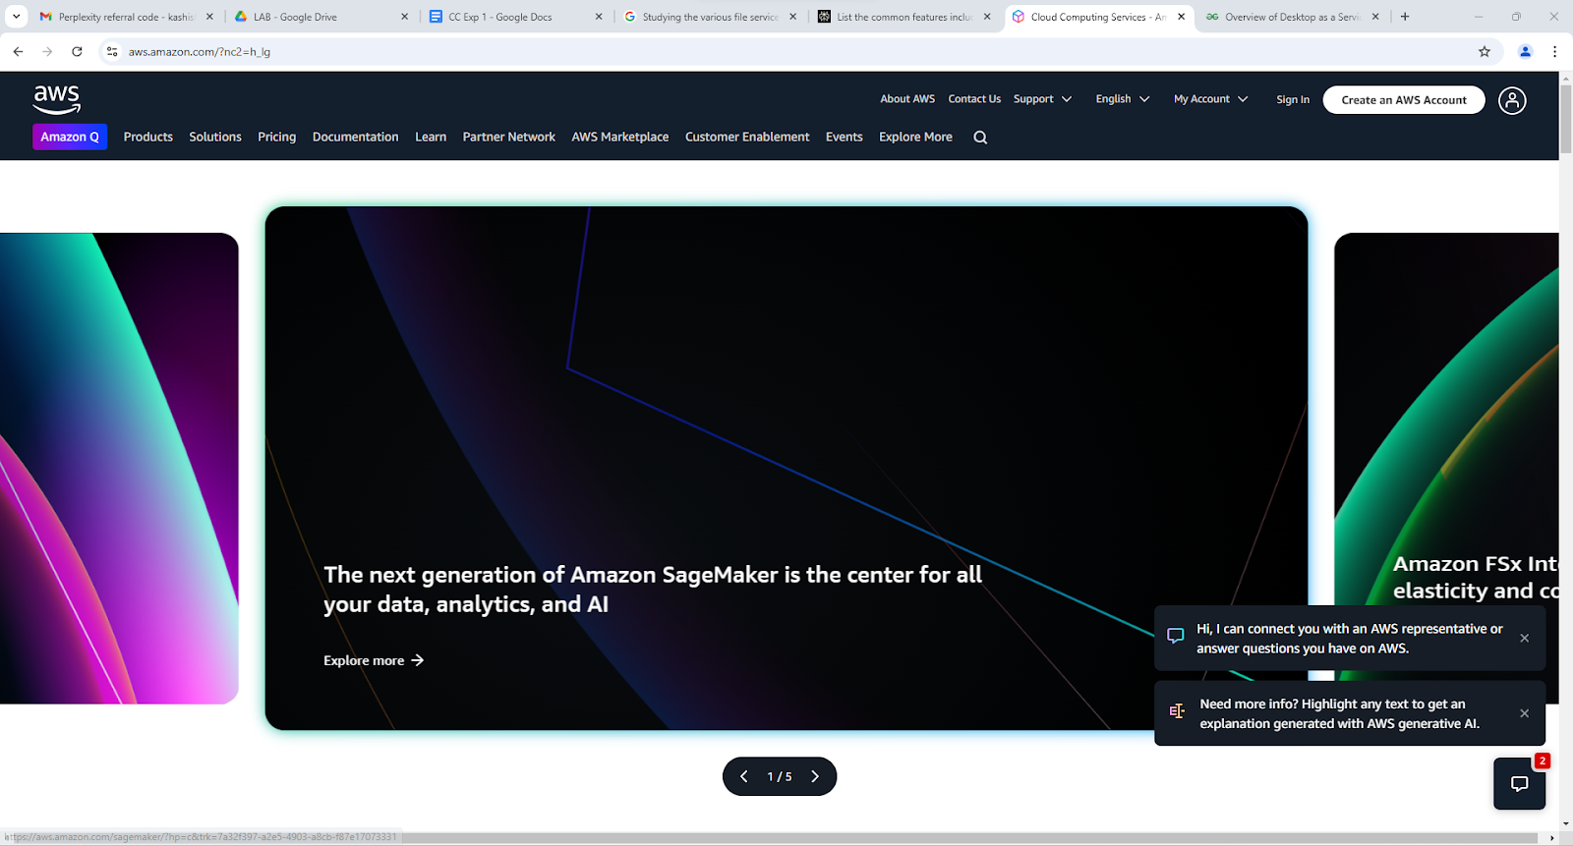
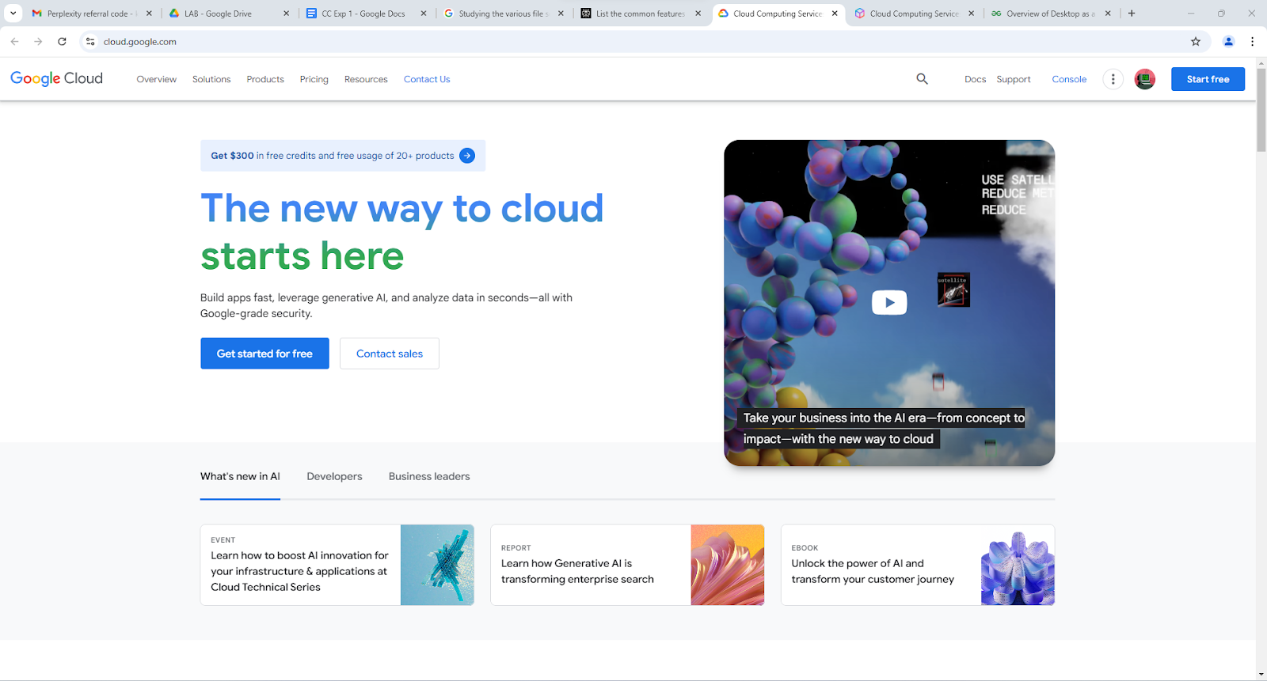
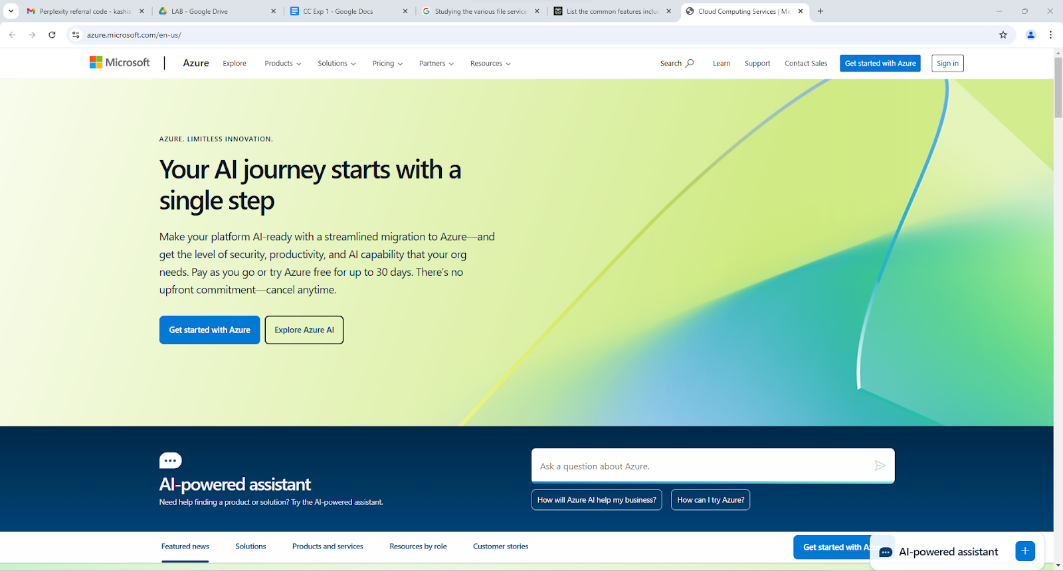
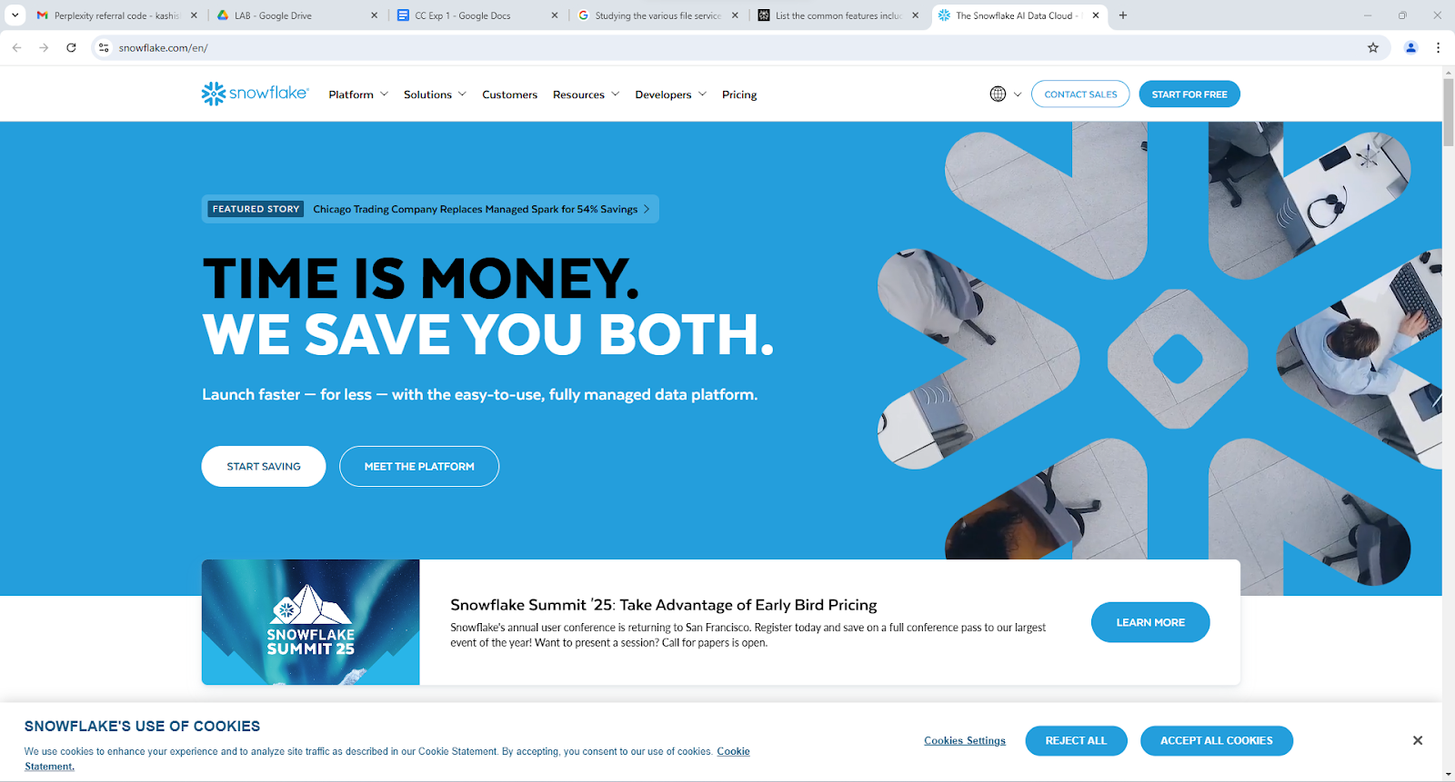
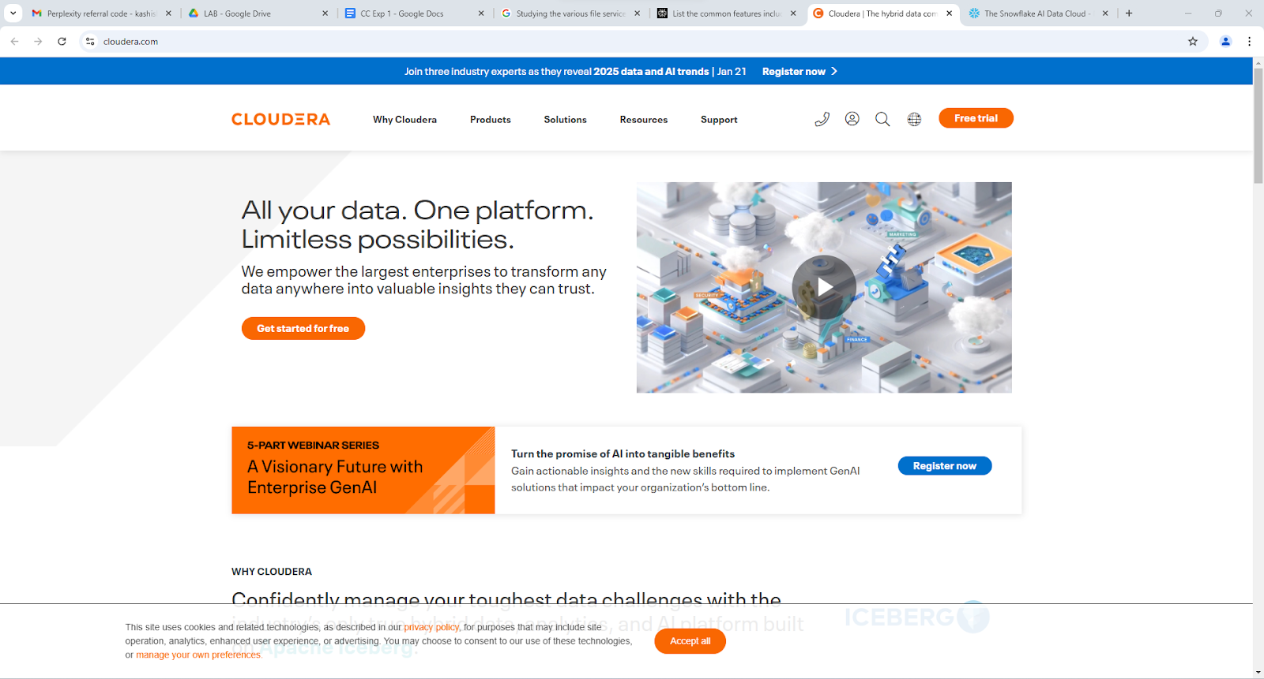

Provider | Price (per user/month) | Mobile App Availability | Storage Space | UI | Sharing Capabilities | Chat Facility
Amazon WorkSpaces | $25 - $250 | Yes | Up to 1 TB (varies by plan) | Intuitive and customizable | Email and link sharing | No
Google Cloud | $40 - $200 | Yes | Flexible (depends on service) | Clean and user-friendly | Social media and email sharing | Integrated with Google Chat
Microsoft Azure | $30 - $250 | Yes | Flexible (depends on service) | Familiar Microsoft interface | Email sharing, OneDrive integration | Integrated with Microsoft Teams
Snowflake | $40 - $200 | No | Scalable storage options | User-friendly dashboard | Email and link sharing | No
Cloudera | $50 - $250 | No | Configurable based on needs | Advanced analytics interface | Email sharing | No

Conclusion:- We studied the NIST definition of Cloud Computing & Architecture.

